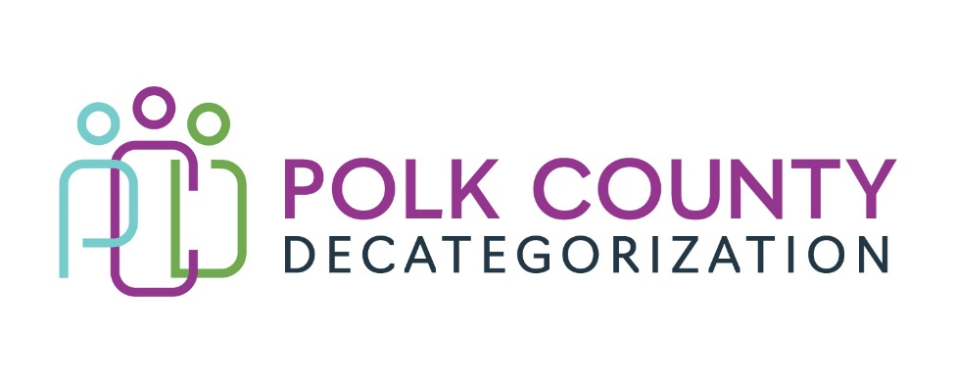

POLK DECAT EXECUTIVE COMMITTEE
Thursday, June 13, 2024
10:00 – 11:30 AM
Family Enrichment Center Conference Room, Polk County River Place

MEETING A G E N D A

- * Call to Order: Eric
Time: _____________________

- * Review and approval of the May 9, 2024 meeting minutes Eric
- See document: Executive Committee Meeting Minutes_05_09_2024
1st ______________ 2nd _____________ Approve: Yes / No

- FY24 Contract Budget Tracking Review
- See document: FY24 Contract Budget Tracking_June 2024 Jaime

- Pre-Arrest Diversion – update and data presentation Jay Hansen

- FY25 Contract Renewal voting Eric and Lisa
- See document: Contract and FY25 Renewal Voting
- Vote on remaining FY25 contract – fiscal agent agreement
- Update on status of contracts approved in prior board meetings

- * Voting item – acceptance of $120,000 FY24 HHS funds transfer
- See document: Designation and Transfer of FY24 Child Welfare Funds Jana
1st ______________ 2nd _____________ Approve: Yes / No

- FY25 Budget and Contract Planning Eric
- See document: FY25 Budget and Contract Planning – as of June 7, 2024
- Review projected unspent from FY24 contracts
- FY25 Decat allocation and potential additional transfer of JCS FY24 funds
- Review overall unencumbered balance going into FY25

- Staffing and internal Decat/CPPC budget Eric
- Decat Coordinator hiring
- Expense considerations due to open Decat Coordinator position

- Other Decat, CPPC, RJCE, PAD updates Jaime, Lisa, Jay

- Board Updates and Other Business All

- Next or Future Meetings: All
- Decat Annual Report
- CPPC Trainings and Meetings

- * Adjourn: Eric
1st ______________ 2nd ______________ Approve: Yes / No

Time: _______________________

Next Meeting:

Choose between July 11th and August 8th

