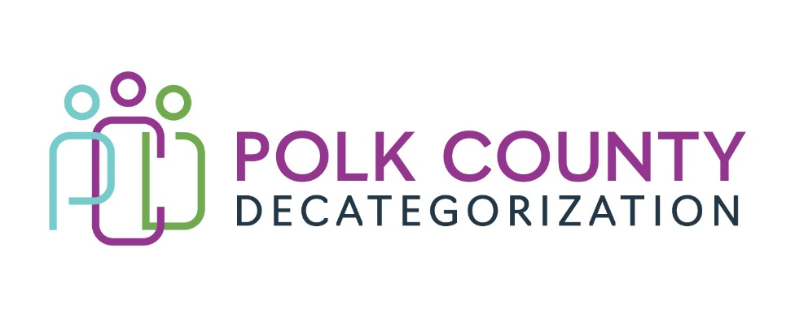

POLK DECAT EXECUTIVE COMMITTEE
Thursday, October 10, 2024
10:00 – 11:30 AM
Family Enrichment Center Conference Room, Polk County River Place

MEETING A G E N D A

- * Call to Order: Eric
Time: _____________________

- * Review and approval of the September 12, 2024 meeting minutes Eric
- See document: Executive Committee Meeting Minutes 09-12-24
1st ______________ 2nd _____________ Approve: Yes / No

- FY25 Contract Budget Tracking Jaime
- See document: FY25 Contract Budget Tracking September 2024

- Polk County Job Study results outcome for Decat Employees. Eric

- Youth Justice Council funding update and discussion Jaime

- SDMT Representative to Executive Board Jaime

- Other Decat, CPPC, RJCE, PAD updates Jaime, Lisa, Jay

- Board Updates and Other Business All

- Next or Future Meetings: All

- * Adjourn: Joy
1st ______________ 2nd _____________ _ Approve: Yes / No
Time: _______________________

Next Meeting:

Thursday, November 14, 2024 – 10:00am to 11:30am – Polk County Family Enrichment Center

