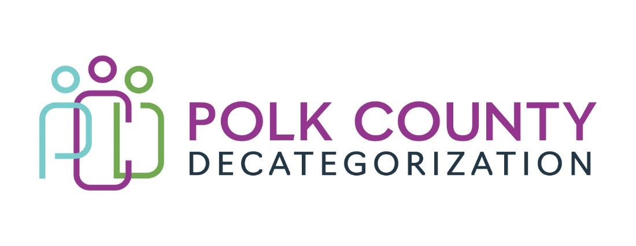

Polk Decat EXECUTIVE COMMITTEE Meeting
Thursday, May 9, 2024

Meeting Minutes

- The meeting was called to order in person at 10:04 am by Joy Ihle. Present voting members were Jana Rhoads, Mindy Norwood, Amanda Marshall, Nicole Davis, Joy Ihle, and Andrea Vitzthum. Also, in attendance were, Jaime Stevens, Jay Hansen, and Lisa Cort from Polk Decat.

- Review and approval of the April 11, 2024, meeting minutes.
  - Andrea moved to approve the April 11, 2024, minutes. Jana seconded to approve the minutes and the motion was carried by unanimous vote.

- FY24 Budget Tracking Review
  - Jaime highlighted contractual expenditures projected to be over as of 4/11//2024.
    - Boys Town projected to be over budget mid-May 2024.
    - Iowa Legal Aid projected to be over budget by the end of FY24. Contract will expire June 30, 2024.
  - Polk Decat/CPPC Coordination Contract is in the process off spending down CPPC funds.

- Des Moines Public Schools Student Support Services
    - Joy presented notes from the Decat teams meeting with Brother 2 Brother and Sisters 4 Success Program highlighting positive impacts of representation of roll models of color.
    - Jana indicated that HHS will not receive any MYFI funds in FY25 to help support this contract.
    - Amanda shared that she has seen the value within the DMPS school system.
    - Jana approved for Decat to purchase $8000.00 for incentive cards from FY24 MYFI funds.

- FY25 Contract Renewal Voting
  - Lisa presented the updated voting results from the April 11, 2024, meeting.
  - DCAT5- 23-141- DMPS Student Support Services
    - Jana moved to approve the Student Support Services Contract using Decat Funds for the entire contract for the purposes of allowing the program a year to plan for alternate funding. Andrea seconded to approve the minutes and the motion was carried by unanimous vote.

  - DCAT5-25-005 – Fiscal Agent Contract- IGA
    - No vote required this meeting. Amanda is awaiting approval on the Justification Letter sent to Janee Harvey with HHS.

- FY25 Legislative and Policy Implications
  - HHS will allow JCS to transfer FY24 dollars to fund JCS contracts in FY25.
  - The process is unclear how JCS will submit the CJCO forms to Director Garcia.
    - There was discussion of how the process was thought to be understood.
    - Jana shared we are currently in a holding pattern.
  - Court Ordered Service funding has been capped through legislation and Amanda will be responsible for tracking all COS spending for the state. HHS will no longer be back filling these orders.

- Approval of FY25 CPPC Report
  - Jaime summarized and identified the top projects the CPPC FY25 plan with the board. The top 3 focus areas are on Immigration and Refugee Services training, Trauma Informed Care trainings and services for the community and families and Youth re-entry from foster care.
    - Andrea moved to approve the report. Jana seconded to approve the CPPC FY25 annual report and the motion was carried by unanimous vote.

- FY25 Budget and Contract Planning
  - Jana provided updates on Decat, MYFI and PSSF funding/allocations.
    - Decat will receive $135,000.00 to be split within the service area.
    - HHS is not receiving any MYFI funds.
    - HHS will receive $51,000.00 in PSSF funds.
      - $11,000.00 will be reserved for Child Safety Conference needs.

- DECAT/CPPC/ PAD updates
  - Jay is currently working on Recidivism reports from CJJP and will share in the June 2024 meeting.
  - DECAT/CPPC did not have anything new to report.

- Board Updates
  - Jana reported that there will be a new universal Flex Form to be used across the state.

- Upcoming meetings:
  - Legislative updates on CPPC/ Decat
  - Vote to approved DCAT5-25-002 Fiscal Agent Contract
  - Budget Tracking
  - PAD Recidivism Presentation

- Adjourn: Andrea moved to adjourn. Jana seconded the motion. The motion passed unanimously. The meeting was adjourned at 10:54a.m.

The next regularly scheduled meeting will be on Thursday, June 13, 2024, at 10:00 a.m.at Polk County Family Enrichment Center. - JS

